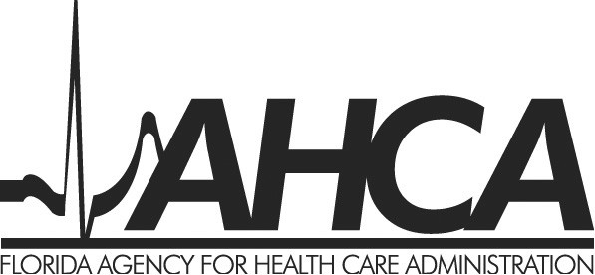

ATTESTATION OF COMPLIANCE WITH APPLICABLE LIFE SAFETY CODES FOR ADDITIONS TO EXISTING HOSPICE INPATIENT FACILITIES/RESIDENTIAL UNITS

STATE OF

COUNTY OF

As Representative of ,
name of hospice provider
I hereby attest that the ______ (enter numeral) beds added to the existing (check one below)
Inpatient Facility (regulated by 42 CFR Part 418; Chapters 400, Part IV and 553, Florida Statutes; and Chapter 58A-2, Florida Administrative Code)
Residential Unit (regulated by Chapters 400, Part IV and 553, Florida Statutes and Chapter 58A-2, Florida Administrative Code)

located at
street address, city, state zip
meet the applicable patient care requirements and life safety codes as stated in the applicable regulations listed above.

I affirm that I have authority to execute this document on behalf of the applicant.

I, hereby swear or affirm under the penalties of perjury that the above information regarding the building expansion is true and correct.

_______________________________________________
Signature of Authorized Representative

_______________________________________________
Authorized Representative (Type/Print Name)

_______________________________________________
Title
This person is personally known to me ____ or produced the following identification
____________________________________________________________________________
Subscribed and sworn to or affirmed before me this _______ day of ______________________
(Month & Year)
_______________________________ Notary State Seal:
Notary Public (Type or Print Name)

_______________________________
Notary Public (Signature)

_______________________________
My Commission Expires

